A PRODUCTION SYSTEM IMPLEMENTATION FOR SEEDING AGROFORESTAL RUBBER (Hevea brasiliensis) UNDER ENVIRONMENTAL CRITERIA FOR FIXING OF CARBON IN THE MUNICIPALITY OF PUERTO LOPEZ, DEPARTMENT OF META – COLOMBIA

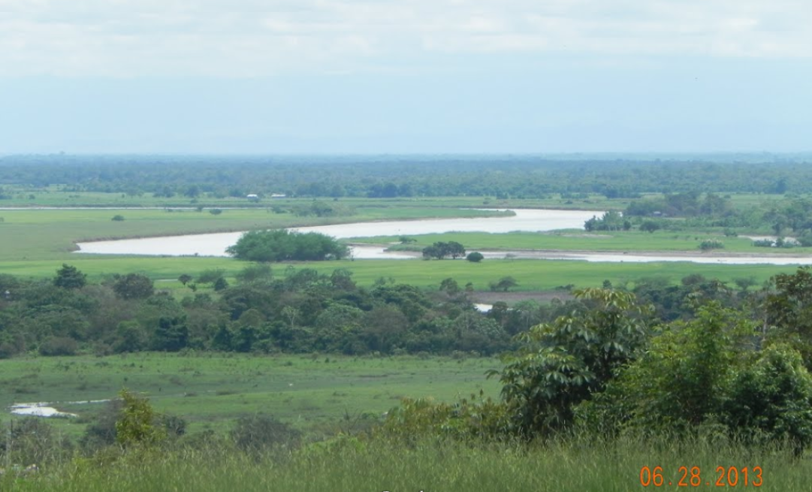
RIO METICA

PROPOSAL: AGROPECUARIA AGUANICA, COLOMBIA, JUNE 2013

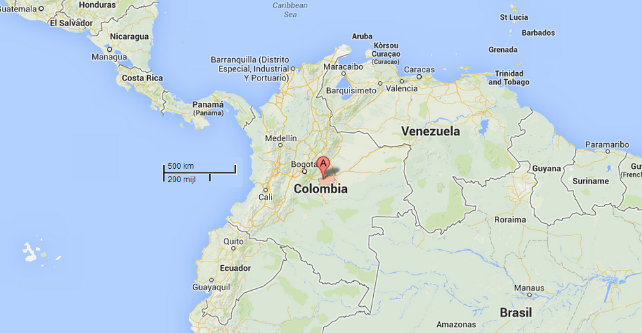
INDEX: CHAPTER

Executive Summary 1-1
Mission 2-1
Company Overview 3-1
Legal Business Description 3-2
Strategic Alliances 3-3
Product 4-1
Current Product 4-2
Research and Development 4-3
Production and Delivery 4-4
The Market 5-1
Market Definition 5-2
Customer Profile 5-3
Marketing Plan 5-4
Sales Strategy 5-5
Distribution Channels 5-6
Advertising, Promotion, PR 5-7
Competition 6-1
Risk/Opportunity 7-1
Management Team 8-1
Capital Requirements 9-1
Exit/Payback Strategy 9-2
Financial Plan 10-1
Assumptions 10-2
Financial Statements 10-3
Conclusion 10-4
Exhibits 11-1

  - EXECUTIVE SUMMARY

Mission to implement 160 hectare productive agroforestry, based on rubber planting, preventing environmental degradation, also getting carbon capture (CO2) and finally wood, helping to reduce pollution, conserving water resources, favoring the generation of biodiversity as part of a new culture of production, consumption and sustainable transformation.

Company Overview … Legal Business Description … Strategic Alliances UNAD, WSF, Local support

Product ... Current Product … Production and Delivery

The Market … Sales Strategy … Distribution Channels … Competition … Risk/Opportunity …

Management Team …

Capital Requirements … Exit/Payback Strategy …

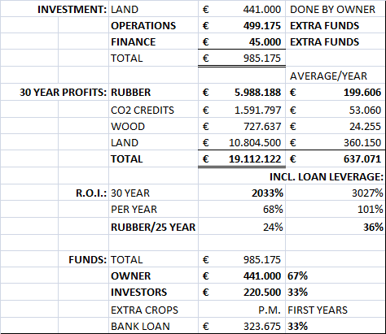

Financial Plan

2-1 MISSION

We pretend to implement a productive agroforestry project, based on rubber planting (Hevea brasiliensis) using strategies aimed at preventing environmental degradation, the sustainability of the project will be given through the first step that is obtaining latex, also getting carbon capture (CO2) and finally wood, helping to reduce pollution, conserving water resources, favoring the generation of biodiversity as part of a new culture of production, consumption and sustainable transformation.

Product or service concept

This project is aimed at obtaining:

- Production of latex (tires, auto parts, industries, gloves and others) will be scratching after six (6) years after crop establishment.

- Green or carbon bonds (reducing global warming emissions): the capture of carbon dioxide (CO2) from the beginning of rubber cultivation but will have significant increases to the extent that larger trees reach.

- Wood from rubber trees (carpentry, joinery, wood construction and others): rubberwood finally be obtained by reducing the productive life of the trees after thirty (30) years after starting the culture.

The above products (rubber or wood) and services (carbon) present in the market unmet demand, with the potential productive action in this field is based on the basis of scientific breakthroughs on criteria of sustainability and competitiveness support capital investment, generating new ideas and promising companies.

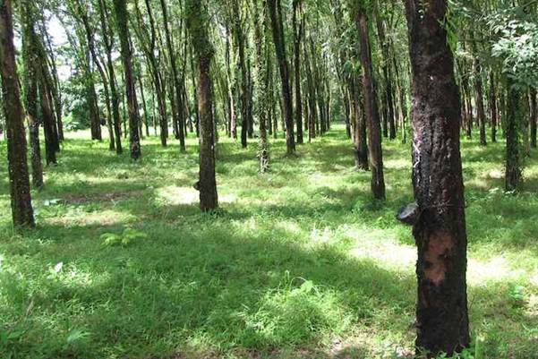

2-2 GENERAL OBJECTIVE

To establish 200 hectares of rubber (Hevea brasiliensis) planting, to obtain latex, carbon capture and extraction, using environmental criteria that are economically sustainable in the municipality of Puerto Lopez, Meta Department, Country Colombia.

Goal. Provide industrialized countries the opportunity to invest in this project, as an alternative to reduce toxic emissions to the environment, through the sale of green or carbon bonds.

2-3 SPECIFIC OBJECTIVES

1. Design and implement a system of rubber production units, for planting, maintenance, and harvesting of latex lined, carbon (CO2) capture and rubber wood.
Goal 1. In each productive unit of ten (10) hectares, we will get steadily liquid latex, and arrange it into molds and sheets, according to the market demands.
Goal 2. Negotiate with the entities issuing the possibility of offering green bonds or carbon (CO2) capture.
Goal 3. At the end of the productive life of the rubber trees, sell the wood for industrial uses.

2. Protect the soil where they develop the productive units of rubber planting.
Goal 1. Provide permanent soil cover with the use of organic matter (leaves, branches) regulating the effects generated by solar radiation, rain and wind.

3. Employ the right techniques in the latex extraction process, to offer a standard product that meets the market expectations.
Goal 1. Register and certify by the Colombian Agricultural Institute - ICA, each production unit, to ensure the health certifications in connection with the activity.
Goal 2. Register each production unit at the Autonomous Corporation in order to obtain the permissions for the mobilization of the obtained products in the project.

4. Contribute to the protection of potential negative effects in water sources surrounding the crops.
Goal 1. Promoting the protection and restoration of watersheds and micro-watersheds, through the production of biomass (leaves, branches, etc.) from rubber, as storers and retainers of water and moisture.
Goal 2. Implement the use of recirculated water for the agro latex process, reducing H20 mt3 per rubber ton.

5. Improve the local economy by generating direct and indirect jobs.
Goal. With the launch of this project we will generate three (3) direct jobs per production unit of ten (10) hectares.

6. Establish from the start of this activity, a friendly relationship with the environment, taking care not to disturb the environment with possible debris or wastes of the production process.
Goal. Zero negative environmental effects obtaining sustainable production.

7. Develop the production cycle with advance planning and scheduling in order to offer products in all seasons.
Goal. Apply a schedule of activities and production.

3-1 COMPANY OVERVIEW

3-2 Legal Business Description

TEXT ANDRES

AND BETTER IMAGE:

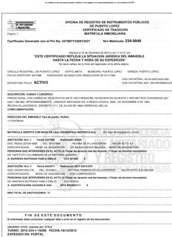

3-3 Strategic Alliances

TEXT ANDRES

4-1 PRODUCT

4-2 CURRENT PRODUCT

The latex will be actually obtained within the first six (6) years after the crop establishment, capturing carbon dioxide (CO2) from the beginning of the rubber trees cultivation. It will have significant increases in the way the trees reach a bigger size. Rubber wood will finally be obtained by reducing the productive life of the trees after thirty (30) years since they were planted.

This project pretends to accommodate a model that will be developed through productive units, each unit of production is then ten (10) acres that will be strategically established so that each production unit becomes an example of working production, applying good agricultural practices (GAP) from planting, maintenance, foundations, agribusiness and marketing.

Rubber and clean development mechanisms

Rubber tree and forest species under the concept of CDM (Clean Development Mechanism), sustainable and friendly to the environment, reduce the volume of greenhouse gases (GHG) in the atmosphere under principles of efficiency economical.

Colombia with its wide diversity of soils, has great potential in the development of crops such as natural rubber, palm oil and forestry, given the magnificent geological and soil conditions for the implementation of agroforestry projects under the CDM concept. It also meets the requirements in the Kyoto Protocol, in other words sustainable development and environmentally friendly.

Considering the natural bounties offered by Colombia for the development of rubber production, we would like to focus an open effort of a company that’s looking for financing, who wants to take productive actions in this most promising national context and for that has decided support the importance of implementing a production system like agroforestry for planting rubber (Hevea brasiliensis) and carbon fixation in the Municipality of Puerto Lopez, Meta Department - Colombia.

Background

The decision to perform an agroforestry project of natural rubber, for the latex production, carbon sequestration, and timber extraction, due to the large market potential and diversity of uses that the rubber has, such as in the automotive industry, footwear industry, plastics and others in the line of wooden furniture, construction and others, in the carbon bond, it is important that you can make the sale of the same, even before the maturity of the trees.

This venture is complemented by the desire to grow, with him trying to create a model of competitive and sustainable production, where its required constant human intervention in the process of preproduction, production and postproduction, creating a company that is identified with the respect, protection of resources and the environment.

4-3 RESEARCH AND DEVELOPMENT

ENVIRONMENTAL CONSIDERATIONS

Soil effects

Rubber cultivation can be considered as an alternative reforestation of areas affected by cutting, burning, or from intensive livestock. There are discoveries that state that this crop improves soil conditions by incorporating large amounts of organic matter (biomass), produced by the decomposition of leaves, flowers and branches in an amount of about 5 to 10 tons / ha / year in a grown plantation. This crop adapts to the conditions of tropical countries and can be used as reforester, recovery, producer and / or protector. It should be noted that the rubber tree has a high capacity with an efficiency of photosynthesis energy use of a 2.8% and a biomass accumulation rate that is superior than the one reported in other forest species. Also, the rate of dry matter production of a rubber plantation that is 5-8 years old is 35 tons / ha / year, wood being 3.3 - 4.0 m3/ha/year, which declines to 15 Ton / ha / year in grown plantations.
Finally, the rubber plantation provides permanent coverage to the ground, regulating the effects generated by solar radiation, rain and wind, helping to improve soil physical properties through continuous addition of organic matter.

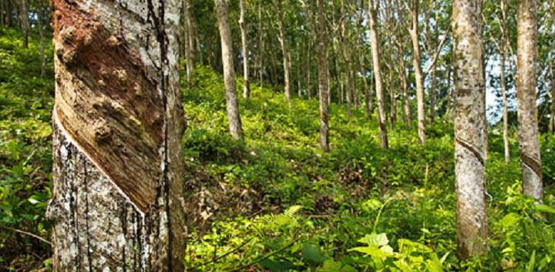

Water effects

The rubber tree cultivation contributes to the recovery of watersheds and micro-watersheds, considering that their permanent contribution of biomass (plant residues such as branches, leaves and fruits) results in increased soil organic matter that plays a role in retention and water storage. However, in the benefit stage the negative environmentals might become to be significant if no preventive measures and control are applied. This happens because the rubber tree processing requires substantial amounts of clean water, which is used for diluting the latex and washing of clots, coagulation canoes, and others. It is noted that the treatment of the latex and the transformation of the clot, requires from 10 to 30 m3 of water per ton of dry rubber, depending on the mode of way of the treatment and the intensity of the washing.

Additionally, the analysis of the effluent indicates the presence of soluble minerals (sulfates, phosphates) and soluble and colloidal fermentable materials (lipids, proteins, carotenoids, sugars, mineral and organic acids) that by chemical and biochemical pathways bring during fermentation to an oxygen consumption at the expense of aquatic life. The pH of the effluent is primarily associated with formic, acetic or citric acid used in the coagulation.

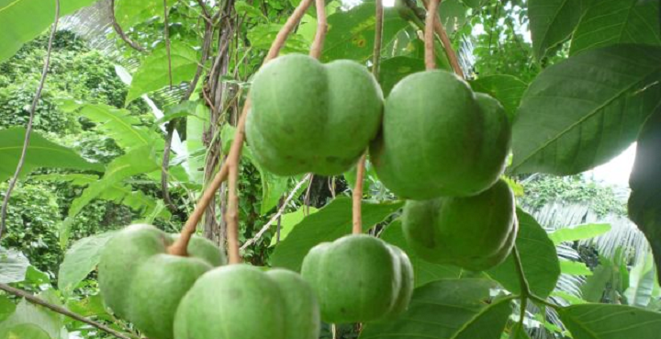

Air effects

Over its lifetime Natural rubber is CO2 capture and fixer, helping to control and reduce the greenhouse effect. It has been found that the amount of CO2 fixed in a rubber plantation in production is 145 tons / ha / year or so. On the other hand the benefit of the rubber phase, can be affected by air quality by offensive odor generation in storage sites especially when the rubber is in the form of clots.

Wildlife effects

The processes of reforestation and soil remediation with natural rubber plantations help to increase the diversity of the fauna and flora of the ecosystems. Additionally, they become habitat of birds, insects and a variety of species, favoring the production of biological corridors and contributing to the conservation of natural resources in the region.

Benefits of rubber cultivation in the agroforestry

The rubber association with other plant species in an agroforestry arrangement called “multiestrata” as Torquebiau and Penot (2004) and Martinez and Garcia (2006), generates the following benefits for the producer :

- Increase in agrobiodiversity since associated in time and space several plant species with rubber.
- Increased capture in the value of atmospheric carbon.
- Increase in the cycle and balance of different nutrients from the soil that results in a decrease of the rubber unproductive stage.
- By partnering several plant species this facilitates the management of pests and diseases of rubber.
- Decrease in economic risks by producing a variety of products.
- Reduces the use of off-farm inputs.
- You can incorporate the rubber agroforestry system to a farm system; the associated species are integrated to other components (for example, pigs or chickens corn for poultry, sugarcane for domestic consumption and for animals, etc.).
- It is faster to reach the point of an economic equilibrium.
- The farmer has with the rubber crops a permanent cash flow while awaiting the productive stage of the tree.

4-4 PRODUCTION AND DELIVERY

PROJECT RATIONALE AND BACKGROUND

Rubber cultivation in Colombia has gained importance in the last years due to initiatives undertaken by regional bodies that have found heveícola activity vital to support the economic development and industrial agriculture. In Colombia, rubber cultivation has been associated with illicit crop substitution programs, promoting agricultural productivity, this gives the crop a social level importance. Rubber cultivation in monoculture generates, according to the reports of the “Secretaria tecnica de la cadena”, direct permanent employment, and three indirect jobs for every four hectares, a figure that increases when we establish agroforestry systems and in addition tos crop with a short cycle, semi-permanent and / or permanent jobs.

Rubber production should evolve according to sustainable consumption patterns in relation to conceptual and legal framework within the action plans developed by the Ministry of Agriculture and the Ministry of Environment, in search of cleaner production to sell in the green markets to promote environmental improvement bonds and corporate competitive transformation.

So the rubber sector should promote strategies that are guided in the following aspects:

➢ Promote the use of natural rubber production under the importance of sustainability and restoration.
➢ Implement new technologies for the production and extraction of natural rubber, without affecting the natural environment.
➢ Prevent environmental degradation that can be generated with the extraction of rubber, promoting clean production.

TEXT ANDRES

- Need the description of planting, growth, rubber harvest, final wood harvest, and clean delevery after 30 years (all with time tables and quantities)

5-1 MARKET

According to the Ministry of Agriculture, rubber cultivation positively impacts productivity in the country, being a sector competitive in the domestic and foreign markets, by improving production processes and marketing, and innovative product development and more value added, all, from the strengthening of science and technological development. Given the wide diversity of products generated from the processing of natural rubber. Current uses of natural rubber worldwide demonstrate, the most important product of rubber consumption is the production of tires, with 67%, followed by manufacturing products from latex which correspond to 11%, being the increased use of latex gloves manufacturing domestic and industrial use, followed by the manufacture of surgical gloves.

According to the Directorate MINAGRICULTURA Technological Development, the main rubber growing problems are due to the low availability of raw material derived from natural rubber to meet the demands of the processing industry, because the production in the country is still small. There is also a variable quality of the material offered due to the low level of technology producers and the use of improper practices of the natural rubber recollection, which has prevented obtaining, standardized raw materials with certified quality.

The cycle of natural rubber and its industry in Colombia requires then, on one hand to provide raw materials that meet the required quality at competitive prices, in national and international markets, and secondly, to find mechanisms for the coordination of the different actors to achieve evenness not only in material and also offer the integration and consolidation of the productive sector.

5-2 MARKET DEFINITION

In the industry transformation of natural rubber in Colombia, there are about 1,126 companies with an estimated gross of U.S. $ 5,705 million in 2003, corresponding to 18.8% of industrial gross production share (DANE, 2003 cited by Proexport, 2003). The rubber industry is concentrated mainly in Bogota with about 275 companies, followed by Antioquia and Valle del Cauca with 75 and 70 companies respectively in Santander is considered that there are 23 companies engaged in the transformation of rubber and in Cundinamarca about 20 (Agrocadenas-CONFECAMARAS, 2007).

Natural rubber utilization in Colombia is given by imports done from this material, due to low domestic production of these commodities, a situation that has represented the gap between agricultural and industrial links. Although there are important projects to increase the hectares of rubber in the country, only a small percentage is currently in production.

Colombia consumes about 16,895 tons of natural rubber latex and considering both natural rubber smoked sheets, TSR, crepe sheets, balata, gutta-percha, guayule, chicle and similar natural gums, natural rubber and others Re-agglomerated natural rubber in other forms (Agronet, 2008). However, natural rubber imports fell by 21.13% compared to the figures reported for 2006, a situation that is related to the startup of some areas planted. Domestic consumption of TSR in the year 2004 to July 2008 was 41,000 tons, with an annual average of 9,633 tons, while the total power in the same period of time for the latex was 33,185 tons with an average annual consumption of 7,644 tons.

The domestic market is largely dominated by Latex through Guatemala, who ranks as the leading supplier of this product with 99.13%. In the case of TSR, the first provider to Colombia is Indonesia, where 86% is imported, however countries such as Malaysia, Vietnam, Singapore, Thailand and Ecuador also compete in this market and therefore should be considered. In addition to these countries, Brazilian rubber cycle presents itself as a leader in the American continent, in respect to land, tons produced, cycle organization and investigation.

More than half of all natural and synthetic rubber produced in the world is meant to the automotive and tire industry, where increasingly it generates a demand for higher quality, implying innovation in both technology and new products.

According MINAGRICULTURA we identified 32 demands that must be met within 12 years, of which there are two types, technological and non-technological, which are:

Technology in culture:

- Availability and variety of certified plant material.
- Technologies associated with the certification process of plant material.
- Agricultural inputs for rubber cultivation.
- Implementation of good agricultural practices.
- Crop agroforestry systems in partnership with rubber and complete utilization of the crops.
- Technological solutions for plant improvement.
- Implementation of quality standards for the process of benefit.

Technology in agribusiness:

- Technological solutions for improving agro-industrial processes.
- Implementation of quality standards for the process of Agribusiness.
- Technologies used in the transformation of the rubber industry.
- Diversification of rubber products.
- Information systems.

Not technological:

- Specific training programs in agribusiness rubber.
- Integration between the cycle links slingshot.
- Trade relations sector.
- Articulation of supply and demand chain knowledge for rubber.
- Effectiveness of research projects and institutions for sustainable development of the sector.
- Management of cost structures, labor skills for cultivation, sangria and benefit.
- Specific training programs in rubber.
- Integration between the cycle links slingshot.
- Trade relations sector.
- Effectiveness of research projects and institutions for sustainable development of the sector.

Due to the above situation, an alternative solution is the implementation of agroforestry systems (Hevea brasiliensis), since it achieves the integration of three (3) components supremely important for industrial development of all countries:

- Production of latex (tires, auto parts, industries, gloves and others)
- Green or carbon bonds (reducing emissions that cause global warming)
- Wood from rubber trees (carpentry, joinery, wood construction and others)

The above products (rubber or wood) and services (carbon) present in the market unmet demand, with the potential productive action in this field is based on the basis of scientific breakthroughs on criteria of sustainability and competitiveness support capital investment, generating new ideas and promising companies.

5-3 CUSTOMER PROFILE

MARKET ANALYSIS

In Colombia the industrial link is made by different companies for the production of finished products make use of natural rubber as raw material. Being wide, both the variety of items made ​​from rubber and diversity of manufacturers, segmentation was performed taking into account aspects such as market size, industry size, quality parameters established, type of raw material used, level technological added value generated and level of expertise. The segments were then obtained tire manufacturers and manufacturers of latex.

Transformation processes associated with this link, vary with respect to both the raw material and the finished product. Thus, in the industrial manufacture of concentrated latex products (gloves) are generally used a series of molds of the desired shape (gloves), which are supported by racks.

The molds are coated with lubricant and are immersed in a liquid latex bath (immersion tank), forming a film on the mold. Thereafter adding a coagulant substance is heated in an oven to solidify the film formed. Then, the gloves are washed to remove proteins and other chemical residues, complementing the curing process by adding sulfur and heating (100-120 ° C) in special furnaces. Finally, the gloves are removed from the mold, inspected, and packaged for sale.

Moreover, the manufacture of tires comprising the steps of grinding and mixing in which the natural rubber type TSR is crushed and mixed with other additives such as pigments, antioxidants, accelerators and boosters. The mixture is fed into a banbury to give complete homogeneity and plasticity to process material. In the molding step, it provides the desired shape for the product and the laminate used in the production of treads, stamping and extrusion, other steps such as preparing and rolling folds are also involved in the manufacturing process. Finally, chemically transformed vulcanization characteristics and properties of the compounds improved strength, elasticity and tensile strength, by the reaction of sulfur with rubber by physical factors such as time, temperature and pressure. Tires are transferred to presses where the molds are installed that provide designs treads and the final dimensions of the tires.

The tire industry in Colombia is made up of companies and multinationals such as MICHELIN GOODYEAR, who own manufacturing plants both in the capital and in the department of Valle del Cauca. Other companies like Bridgestone and Pirelli have a presence in the domestic market but only dedicated to the marketing of tires produced in other countries. These industries handle about 70% of rubber market in the country, of which 37% is owned by Goodyear in Colombia, and 31% to the Michelin tire shop.

Additionally, the segment is in a highly competitive environment, not only among listed companies but also for smuggling detected in the sector. However, the increase in the number of vehicles has contributed to a steady growth of 25% of the tire industry in recent years.

Goodyear Colombia SA has a history of 62 years in the country, being the leading manufacturer of truck tires and OTR (backhoes and bulldozers) which, to manufacture, use 40% to 50% of natural rubber, 30% of synthetic rubber and other additives such as carbon black, antioxidants, oils and fats, rayon fiber and steel. The plant, located in the Chain of Rubber.

Of the units produced, 80% is owned truck line while 20% is in agricultural machinery. Goodyear exports 80% of its production to neighboring countries such as Venezuela, Ecuador, Chile, among others, recording averages of 214 662 units. Natural rubber used is brought from Indonesia or Guatemala by its subsidiary in Peru, showing average prices of U.S. $ 2.9 per kilogram and have an approximate consumption of 750 tons per month. It manages a stock of 35-45 days for natural rubber, place orders every 3 or 6 months depending on production schedules. Goodyear has a 20% Colombian suppliers including the company stands CABOT SA supplier of carbon black.

The glove manufacturers segment, consists of about 342 companies engaged in manufacturing and / or marketing of gloves, among which with production companies nationally and Eterna SA, Ladecol, Indulatex Ltda located in Bogota and Latexport in Guarne township in Antioquia. Eterna SA has a 5% market share of rubber being one of the most important industries of gloves. Other companies already mentioned, capture the 3% and 2% rubber market according to their share in sales. Due to the lack of domestic production of latex, are imports of the raw material that meet the internal needs of the input, recording amounts up to 7,644 ton / year with average values ​​of $ 1.31 / kg latex consumption has experienced an average annual growth of 4.12%. Sempertex SA is the largest importer of latex with 26% of imports.

Eterna SA consumes 14% while Ladecol Indulatex 11% and 9% brought from Guatemala, whose price in 2008 was not constant. On the other hand, Latexport consumes about 60 ton / month representing 7% of national consumption. The raw material for these industries is provided by Guatemalan suppliers, with whom they have established business for over 12 years. Interviews conducted in the field, in 2007 there were strong price variations due to the global shortage of raw material.

Companies segment glove manufacturers have a long history of around 30 years in the market. The technological level of the manufacturers of gloves differ as to the drying equipment used and the type of processes implemented either continuous or batch. The machinery is of Colombian manufacturing, which made constant maintenance and necessary parts are replaced. The process of automatic machinery used surgical gloves but mostly this type of gloves is imported from countries such as Malaysia. Companies like Latexport employ automatic machinery for packaging the finished product while companies like Indulatex perform this operation manually. Indulatex produces about 45,000 dozen gloves between household products and toiletries have 4 production lines and established work on inventories, production scheduling according to stock necessary. This scheme is similar to that found in other companies in the segment.

Processed products are sold directly to major brands, own brand managing concessions such as Macro, Success, Carulla, Olympic and other additionally each manufacturer has its own brands of gloves being the most traded domestic use. They also have distribution of its products in convenience stores through authorized distributors and own sales force. They have experiences of exporting to countries like Venezuela and Peru by marketers but the Colombian market Bogotá is the largest being the most important. It is estimated that the glove industry generates 400 jobs / company but mainly leveraged grooming sector in which manufactured waxes and other complementary products.

In the analysis of quality, the tire industry has quality standards for their products, because the tires are considered a security article must therefore go through stringent checks before being put on the market. Transformation plants of the two major tire companies located in the country have significant investments radial technology level, allowing them to ensure their consumers a product developed with high quality standards. The two companies have the ISO 9000 implementation. As for the glove industry, include the adoption of technical standards as the NTC from 1725 to 1726, and some companies like Latex port in Antioquia is certified with ISO 9001 as Eternal in Bogotá.

The manufacturers of gloves performing inspection one by one from the products made by which ensure durability. According to information provided by companies, it is considered that about 3% of the production suffers rejection by the quality department, so have implemented strategies to generate ideas rejected material utilization, initiatives have gone largely the same workers in companies with due recognition of management. Glove industry, raw materials are analyzed in terms latex ammonia content, mechanical stability and solids content. In general supplier relationships are very stable, in the case of Indulatex, manufacturer of gloves, has been working with your provider about 12 years due to its quality maintenance, and certification of your material.

5-4 MARKETING PLAN

MARKETING STRATEGIES

TEXT ANDRES - practical

The initial penetration strategy will be, distributed by geographical area, the main cities of Colombia, to the advisor (s) may attend and monitor these areas, offering products to companies that currently buy latex, the differentiating factor is that the sales consultant known as the technical basis of the product, therefore the skills to argue handle the physical and mechanical properties of the product, and likewise to businessmen will be invited to participate actively in laboratory tests (physical and mechanical ) for the potential and uses of the product, the above is to increase the level of awareness and brand recall.

5-5 SALES STRATEGY

TEXT ANDRES - need “how to sell”

The sales consultant in addition to supporting the marketing of the product, visit the customer rutero assigned zoning will also be responsible for giving know the products as rubber wood and carbon developed by the company in events such as fairs and exhibitions the automotive, industrial, construction and others.

Then, carry out visits to potential new customers through referrals from other customers.

----

PRICE STRATEGY

From the start of sales will be handled a price of $ 5,000 for every kilo of natural rubber laminate, VAT (16%) is paid by the customer, the price is according to the product and not incurs on costs to consumers, distributors or intermediaries.

The customer pays for each kilo of rubber laminate according to its quality, ex strength, elasticity, grip, behavior as temperature and other factors that influence buyer requirements.

The pricing is the result of the estimated unit cost of raw materials, cost of unit labor, manufacturing overhead costs and other technical indicators - economic project.

In relation to the payment terms set cash payment and product delivery will take place after confirming deposit in the bank account of the company, for customers who demonstrate a good payment morality, may be credit initiate a process to 8 days, 15 days and one month, a strategy that would be implemented three years from start-up company.

To withstand a possible price war will implement a risk analysis matrix where they undergo the limit selling prices, raw material cost unit, cost of labor, manufacturing overhead costs, after this analysis decisions will be taken to sensitize the critical points.

ADVOCACY

The sales advisor, product samples delivered to employers subject to market, these samples shall be accompanied by technical specifications, which establishes the physical and mechanical behavior of each product, an invitation will be scheduled with each employer to attend a specialized laboratory to be tested physical, chemical, mechanical, and understand the potential and uses.

COMMUNICATION STRATEGY

The communication strategy will create a database of potential customers, managers will be contacted to arrange a visit, introduce the company and offer a portfolio of products and services.

After offering the products and deliver samples, a separate date for laboratory assistance, product demonstrations, this invitation will be accompanied, personal presentation card, brochures and product data sheet.

Among the activities that will develop the sales consultant, will be participating in events and fairs, will create a demonstration booth or points where corporate image is displayed on the company with a logo that has recall, will be given to potential customers, staff business cards, brochures, accompanied by a flashy banner of a size (2 m wide x 3 m long).

It will develop a web page, where customers can find all the information about the company, products, technical services, consulting, mission, vision, orders, quotes and others.

Also implement a customer service model, through a hotline.

SERVICE STRATEGY

In product marketing offer suggestions and recommendations on handling, processing and storage of natural rubber, same shall take delivery of any complaint or claim which is generated by customers.

The priority of this company will provide quality, timely deliveries, technical support, production volumes, real technical solutions and competitive prices, accompanied by a sales department that provides support to our customers on technical issues, new products, laboratory tests and other .

As a guarantee of the product line will create a customer and technical support, where they take delivery comments, questions, complaints and claims, together with technical advice.

It is important to note that to ensure product quality, we will implement a quality management system within the company to ensure quality product.

SALES PROJECTION

Portfolio POLICY

Initially sales of the product will be made in cash, as the company has a sales growth would be possible to credit.

The company operate a bank account where it will be verified payments made by customers, after verification will proceed to deliver the goods.

5-6 DISTRIBUTION CHANNELS

DISTRIBUTION STRATEGY

The distribution of products is done following parameters such as frequency of consumption volumes required, geographic location, etc.., The domestic market will be taken care of initial form but expect to export then to strengthen the business model in the country.

TEXT ANDRES – but need more practical info (distribution by car, train, vessel)

5-7 ADVERTISING, PROMOTION, PR

6-1 COMPETITION

7-1 RISK/OPPORTUNITY

8-1 MANAGEMENT TEAM

9-1 CAPITAL REQUIREMENTS

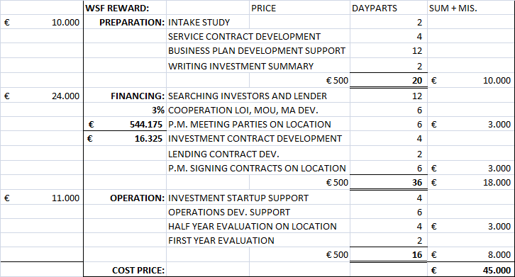

9-2 EXIT/PAYBACK STRATEGY
10-1 FINANCIAL PLAN

10-2 ASSUMPTIONS

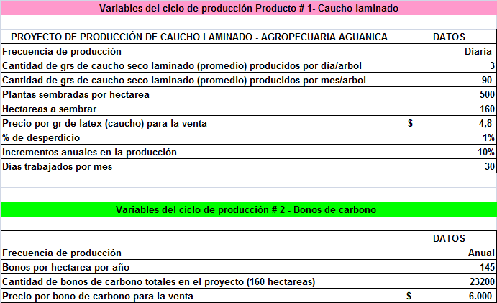

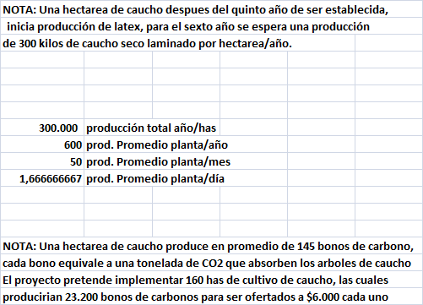

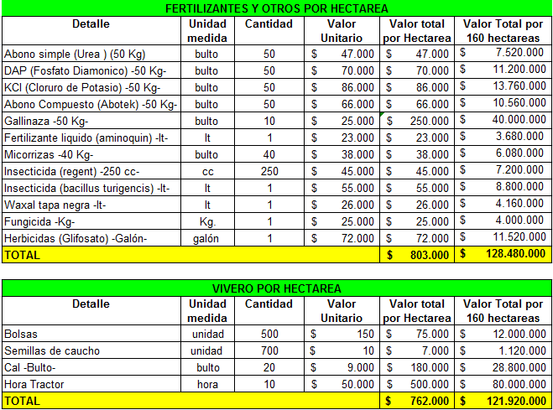

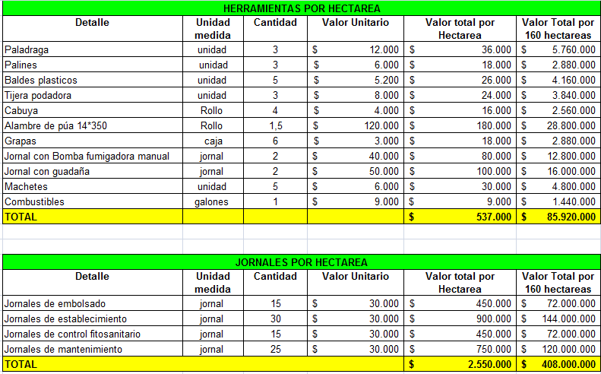

10-3 FINANCIAL STATEMENTS

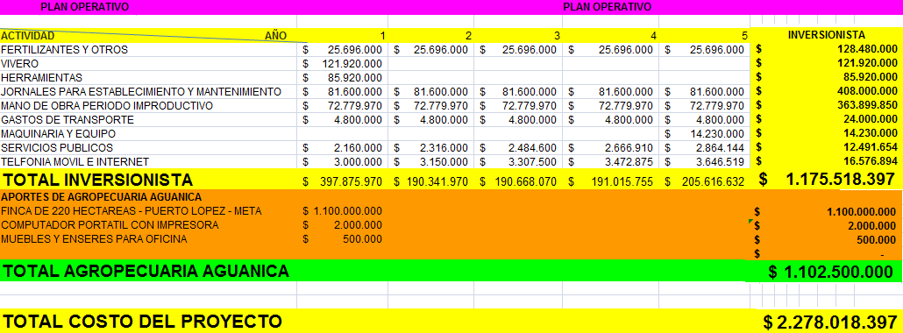

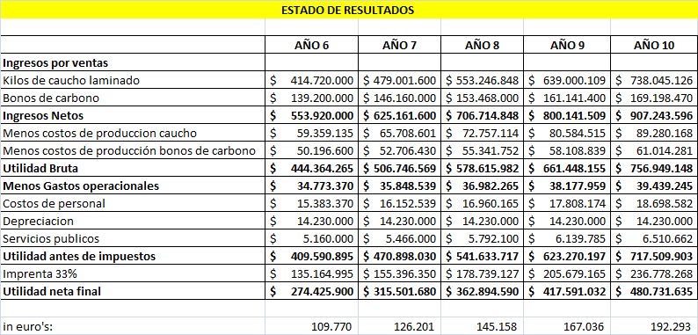

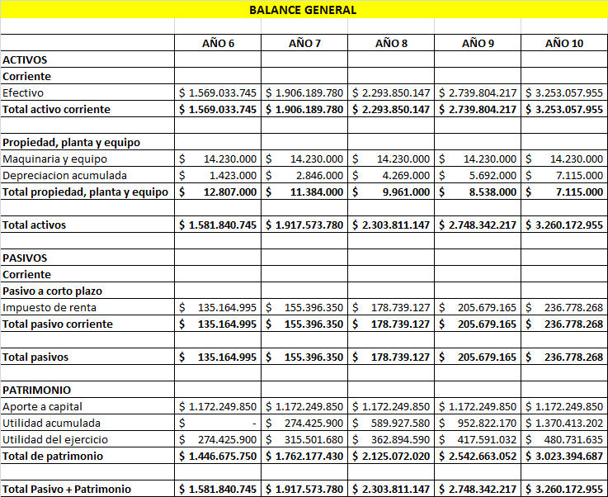

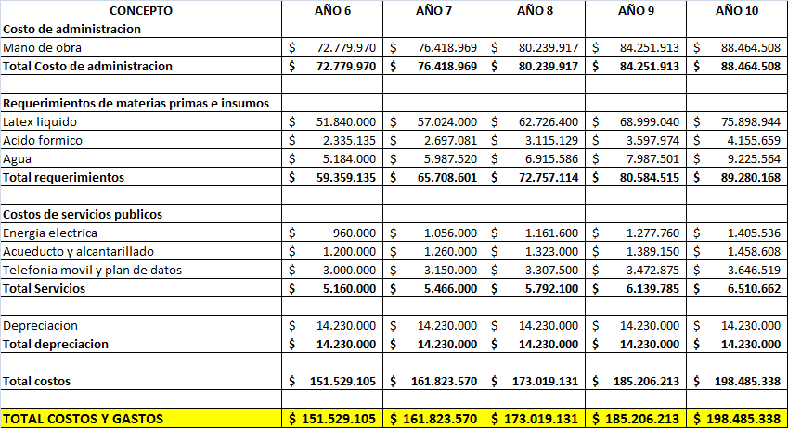

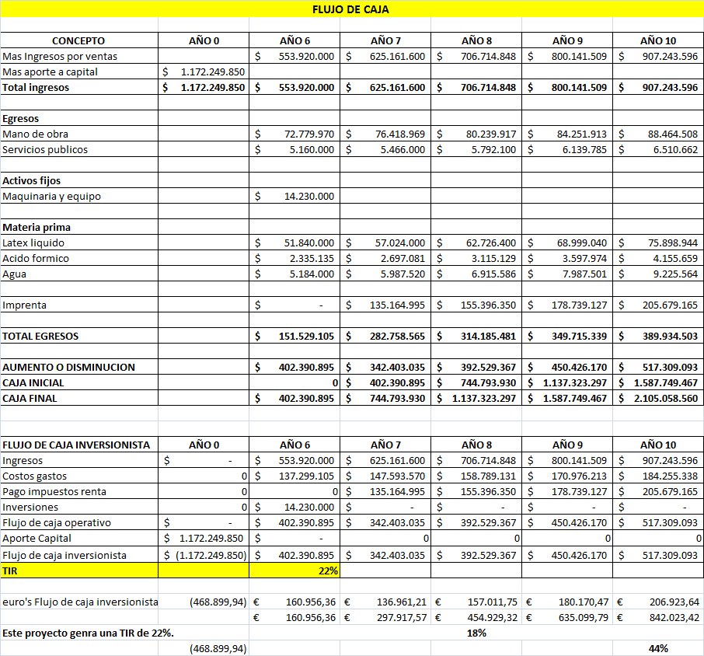

Colombia Producer Prices | Actual Value | Historical Data | Forecast
www.tradingeconomics.com/colombia/producer-prices‎
Colombia Producer Prices averaged 96.25 Index Points from 1999 until 2013, ... InColombia, the Producer Price Index measures the average change in price of ...

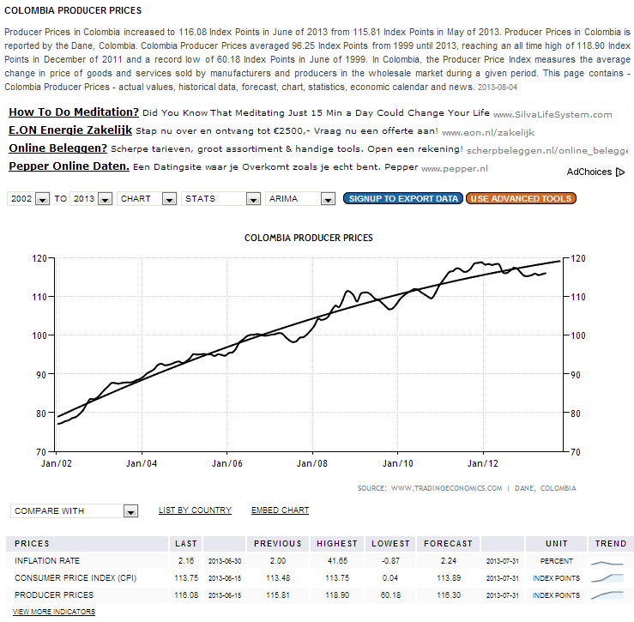
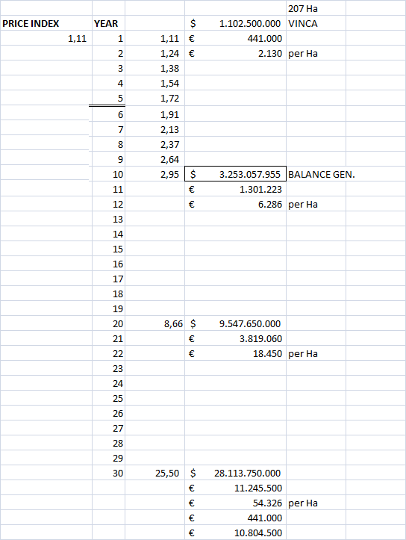
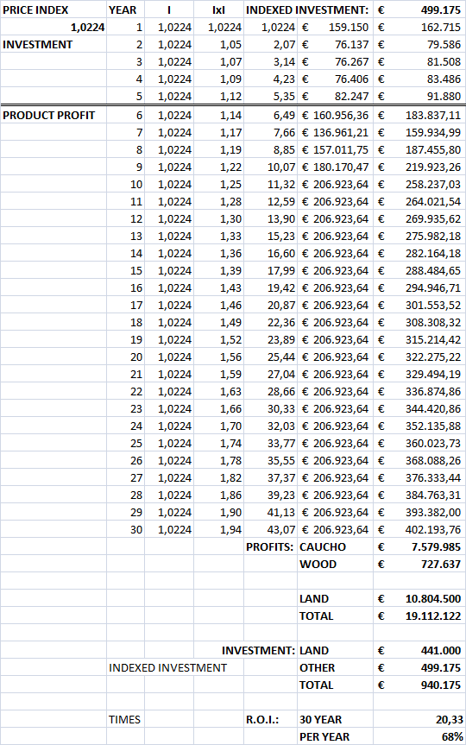

10-4 CONCLUSION

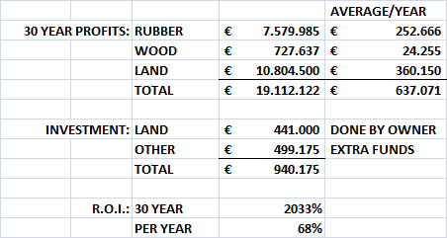

11-1 EXHIBITS

